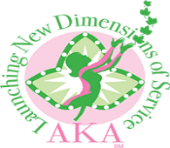
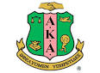
ALPHA KAPPA ALPHA SORORITY, INCORPORATED®
Delta Xi Omega and Alpha Xi Chapters
Chapter Committee Meeting
10:00 a.m., September 22, 2018
Business and Community Center
Soror Sh’Myra L. Moore, Basileus, Presiding

“Keeping our legacy alive through new dimensions of service: Program Excellence, Community Partnerships and Active Participation.”

AGENDA
Call to Order Soror Sh’Myra Moore
Meditation Soror Fonda Kirk
Adoption of Agenda
Approval of Minutes Soror Lovetta Moore
Reading of Correspondence Soror Sh’Rae Moore

Officers’ Reports
Pecunious Grammateus Soror Renese Bates
Tamiouchos Soror Carolyn Holt
Hodegos Soror Marsha Pruitt
Graduate Advisor Soror Stephanie Morgan
Committee Reports
International Program
HBCU For Life Soror Lovetta Moore One Million Backpacks
Playground Impact Day Soror Sarah Lightner International Day of Prayer Soror Sh’Myra Moore
Fiscal Responsibility Soror Walillian White
Global Impact Soror Sakia Sellars

Standing Committee Reports
Audit Soror Sarah Lightner
Health Soror Earnestine Krider
Fundraising Soror Shelia Brown-Miller

Unfinished Business

New Business
68th Boule Delegate’s Report

Philacter Report Soror Stephanie Morgan

Announcements
October Chapter Meeting- October 20, 2018- 10:00am- Business and Community Center

Adjournment Sorority Hymn and Pledge

