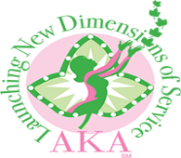
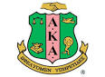
ALPHA KAPPA ALPHA SORORITY, INCORPORATED®
Delta Xi Omega Chapter
Executive Committee Meeting
6:00 p.m., October 4, 2018
Jerusalem Baptist Fellowship Hall
Soror Sh’Myra L. Moore, Basileus, Presiding

“Keeping our legacy alive through new dimensions of service: Program Excellence, Community Partnerships and Active Participation.”

AGENDA
Call to Order Soror Sh’Myra Moore
Meditation Soror Fonda Kirk
Adoption of Agenda
Approval of Minutes Soror Lovetta Moore
Reading of Correspondence Soror Sh’Rae Moore

Officers’ Reports
Pecunious Grammateus Soror Renese Bates
Tamiouchos Soror Carolyn Holt
Hodegos Soror Marsha Pruitt
Graduate Advisor Soror Stephanie Morgan
Committee Reports
International Program Soror Lillian Morgan EETSS Program Launch
Upcoming Program Events
Team Leader Responsibilities

Standing Committee Reports
Finance Soror Carolyn Holt
Fundraising Soror Shelia Brown-Miller
Nominations Soror Earnestine Krider
Sisterly Relations Soror Tanya Dixon- Neely

Unfinished Business

New Business

Philacter Report Soror Stephanie Morgan

Announcements
November Executive Committee Meeting- November 1, 2018- 6:00pm- Jerusalem Baptist Church

Adjournment Sorority Hymn and Pledge

